Assignment-9: Platform Migration

To migrate a computing platform, the following steps are recommended:

* Defining the scope of migration plan and planning a strategy (3-1-2023 -> 3-3-2023)
* Assessing the present environment for finding the components to be migrated

(3-4-2023 -> 3-5-2023)

* Identifying the target environment (AWS, Azure etc.,) to migrate the computing platform. (3-5-2023 -> 3-6-2023)
* Get the estimation size of storage and find the storage destination.

(3-6-2023 -> 3-8-2023)

* Assessment of the network by benchmarking the performance and by using iperf
* Take the snapshot of metadata. (3-8-2023 -> 3-11-2023)
* Identify compatibility issue between present and future platform

(3-11-2023 -> 3-13-2023)

* Develop a plan that includes resource requirements and procedures

(3-13-2023 -> 3-15-2023)

* Be sure to build in enough time for unexpected issues that may arise during the migration process. (3-15-2023 -> 3-16-2023)
* Identify any dependencies that exist between different parts of the platform or between the platform and other systems. (3-16-2023 -> 3-18-2023)
* Develop contingencies in case something goes wrong during the migration. For example, you might have a plan in place for how to handle a data migration failure, or you might have **backup resources** available in case a critical system goes down during the migration. (3-18-2023 -> 3-22-2023)
* Identify who will be responsible for each aspect of the migration process.

(3-22-2023 -> 3-23-2023)

* Develop a communication plan to ensure that everyone involved in the migration process is kept up-to-date on progress, issues, and other important information.

(3-23-2023 -> 3-24-2023)

* Prepare the current environment and the target environment for the migration, including setting up the necessary infrastructure, software, and security measures

(3-24-2023 -> 3-25-2023)

* Perform the actual migration, following the procedures outlined in the migration plan. (3-25-2023 -> 3-29-2023)
* In the implementation part, we need to use split to rsync different sublevels.
* We need to use the multiple network adaptors for doing the fast transfers.
* Verify that the migration was successful and that all components are functioning as expected (3-29-2023 -> 3-30-2023)
* Monitor the new platform to identify any issues and optimize its performance as necessary (3-30-2023 -> 4-3-2023)
* Document the entire process for the successful completion of the migration process

Regarding the cloud migration services from AWS we can use:

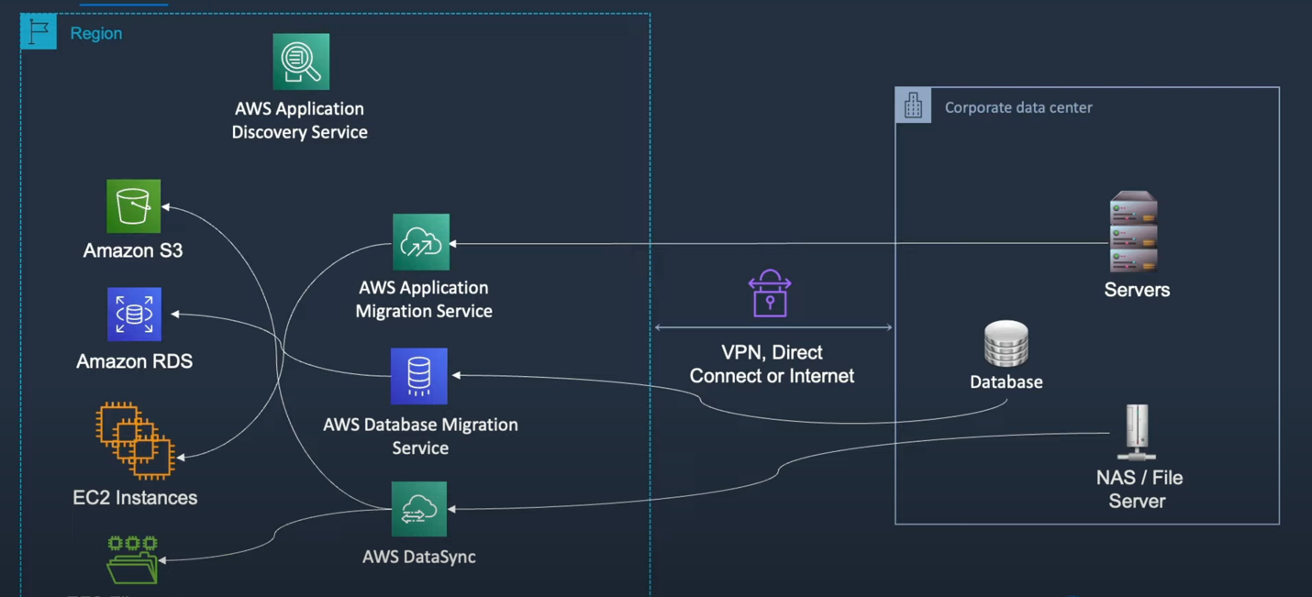

Updating individual WS EC2 profile to csye7374Student :



